Student
Course
Institution
Instructor
Date
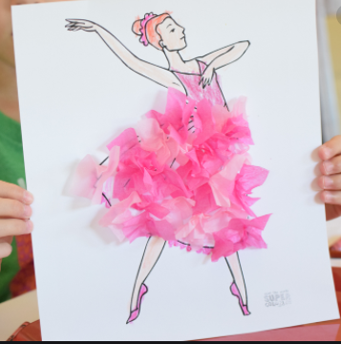

Description
I chose to use a hand drawing to set my design. Since the play is Ballerina Flowers, I decided to use a woman dancing to represent Ashley’s mum, whose main dream was to dance for the Queen. Ashely's friends-Emily, Hannah, Sarah, and Taylor were willing to help Ashely in fulfilling her mum's wish. The setting is also contemporary since the dance happened in one day and one event.
Explanation
The use of pink flowers symbolizes the flower drawing that Ashely was drawing when she was joined by Emily, Hannah, Sarah, and Taylor. A single-woman in the drawing also represents the loneliness that Ashely was experiencing after the death of her mother. The flowers in the drawing also represent the flowers that were given to Ashley by Hannah.
The flowers symbolize how life is fragile. Ashely's mum had a dream to dance before the Queen but it was cut short after meeting her death. However, the friendship that Ashely had helped her to fulfill her mother's wish. This means that there is hope even after death. Ashely's friend helped Ashely to make the dream of her mother possible through a play.

